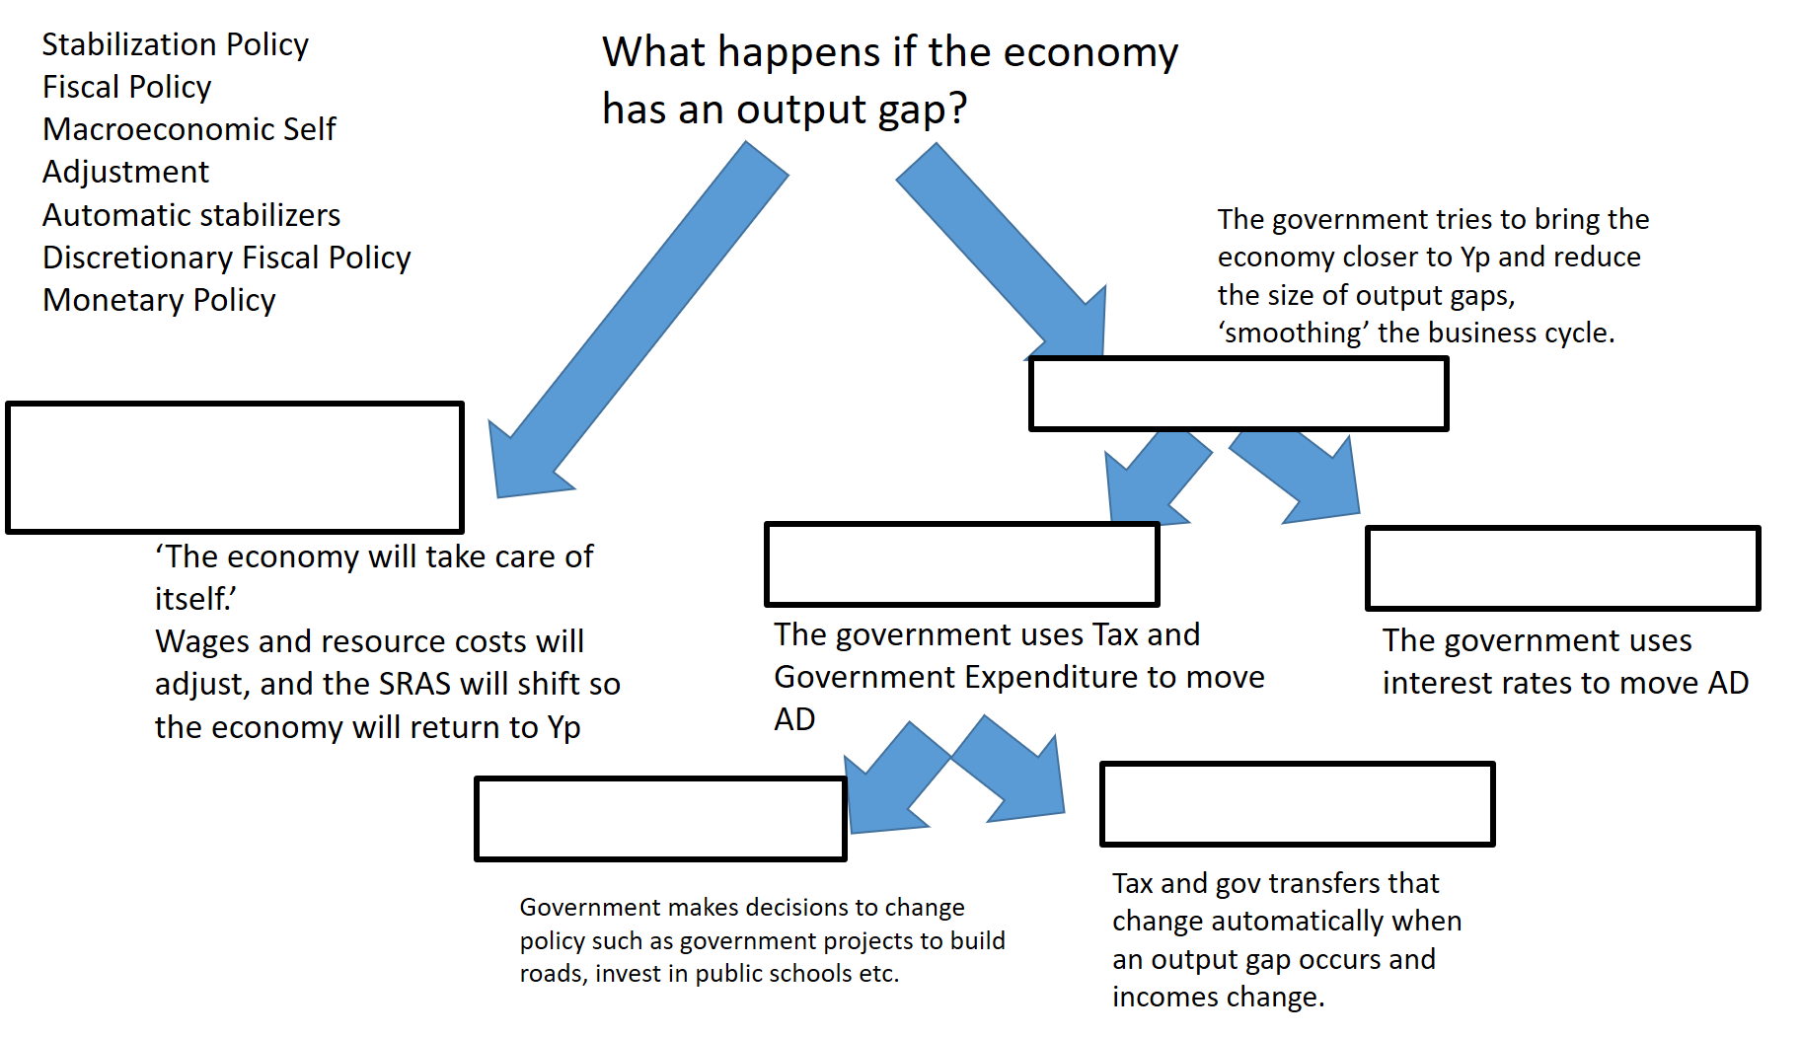

Macroeconomic automatic adjustment and automatic stabilizers ________ (are/are not) the same. ________________________ occurs when the wages/resource costs become _______________(sticky/flexible) in the ______(LR/SR) which causes the _________(SRAS/AD/LRAS) to shift, returning the economy to Yp. __________________________ on the other hand, must involve the government and is a type of fiscal policy. The tax policy and government transfers policy that was already set, will automatically change when there are output gaps. In a ____________(positive/negative) output gap, incomes will _______(increase/decrease) which will cause tax to __________(increase/decrease). Furthermore, ________ (more/less) people will qualify for government transfers and so government transfers will _____________(increase/decrease). The effect will be _________________(expansionary/contractionary) and _________ (increase/decrease) the size of the output gap.

